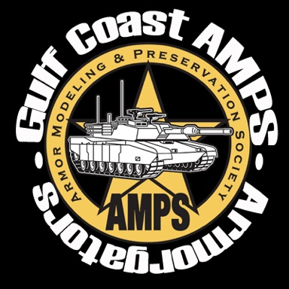
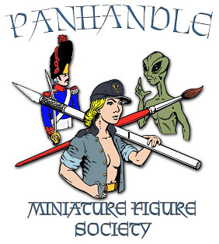
The Panhandle Miniature Figure Society (PMFS) and the Gulf Coast Chapter of the Armor Preservation and Modeling Society (AMPS) present an
Armor Model & Miniature Figure Contest
- When: From 9AM to 5 PM on 15 April 2023 (Saturday)(Vendor set up from 4-8 PM on 14 April and starting at 8AM on 15 April)
- Where: Santa Rosa County Auditorium (4530 Spikes Way, Milton, FL 32583)
- Admission: $5 (General); $10 (Family); $20 (5-entries in either contest); $1 (each additional entry in either contest). Vendor Tables: $20 each (2.5’x8’)
- Armor Theme: Amphibious Combat Vehicles (swimmers or deep waders)
- Model Figure Theme: TBA
- General Information:
  - PMFS operates its competition under the Chicago “Open System” (Gold, Silver, Bronze) in which entries are judged independently on merit. Judges Best of Show Award will be given to the entry deemed most outstanding by the judges from all entries. People’s Choice Award will be selected by popular vote from the competitors.
  - The AMPS side of the contest will be an officially sponsored AMPS event and feature all AMPS categories (except Masters and Figures) and be peer judged by AMPS rules. Pre-registration and forms for AMPS can be found at https://armorgators.org/ , FaceBook (“Armorgators”) or email below.

- Contact: Vendor POC: John Struck, johnsmodels@hotmail.com, (850) 968-6008); AMPS POC: Bob Edwards at LTCEdwards@att.net; PMFS POC: Bob Waltman at rwaltman3@outlook.com.

