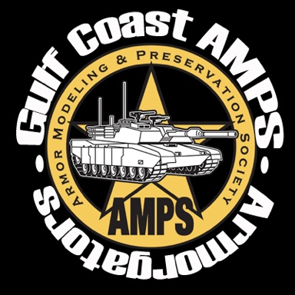
The Gulf Coast Chapter of the Armor Preservation and Modeling Society (AMPS) presents an
Armor Model Contest
- When: From 9AM to 5 PM on 26 April 2025 (Saturday)(Vendor set up from 4-8 PM on 25 April and starting at 8AM on 26 April)
- Where: Santa Rosa County Auditorium (4530 Spikes Way, Milton, FL 32583)
- Admission: $5 (General); $10 (Family); $20 (5-entries in either contest); $1 (each additional entry in either contest). Vendor Tables: $25 each (2.5’x6’)
- Armor Theme: At the Zoo (Armored vehicles named after animals – See website of FB page for additional details)
- Co-Host: Panhandle Miniature Figure Society. Two contests in one! Registration fees cover both contests.
- General Information: The AMPS side of the contest will be an officially sponsored AMPS event and feature all AMPS categories (except Masters and Figures) and be peer judged by AMPS rules. Pre-registration and forms for AMPS can be found at https://armorgators.org/ , FaceBook (“Armorgators”) or email below.
- Registration: AMPS Pre-registration is available on line. Early registration: Friday, 5-8 PM). Show registration: Saturday, 9-11 AM. Registration closes at 11 AM Saturday
- Contact: Vendor POC: John Struck, johnsmodels@hotmail.com, (850) 968-6008); AMPS POC: Bob Edwards at LTCEdwards@att.net; PMFS POC: Bob Waltman at rwaltman3@outlook.com.


Lodging

All lodging about 10-15 minutes away from the event site. Of course, there is no shortage of lodging in Pensacola proper.
- Best Western Milton Inn. 8936 Highway 87 South, Milton 32583
- Red Roof Inn & Suites Pensacola East. 2672 Avalon Boulevard, Milton 32583 (Closest to show)
- Holiday Inn Express & Suites Milton East I-10. 8510 Keshav Taylor Drive, Milton 32583
- Military lodging is potentially available at Whiting Field NAS

Military-Themed Attractions

All listed below have a Web presence.

Local
- National Naval Aviation Museum. 1750 Radford Blvd, Pensacola, FL 32508. Now open to the public. Free (donations accepted).
- Hurlburt Field, USAF Special Operations Command. Not advertised since you need an ID card to get in, but the memorial park next to the main entrance is very nice and filled with “spook” aircraft. Free.
- USAF Air Armaments Museum, 100 Museum Dr, Eglin AFB, FL 32542. Off base and open to general public. Lots of aircraft on display, both inside and out. Free (donations accepted)

Nearby
- USS Alabama Battleship Memorial Park, Mobile AL. Admission to the park (featuring the battleship, an aircraft pavilion, a submarine, and outside armor and aircraft displays) is around $20 for an adult.

(Relatively) Nearby
- Mississippi Armed Forces Museum, Camp Shelby MS (South of Hattiesburg). Nice US armor displays outside and very nice museum. If an ID card holder, you might be able to talk an armory manager into letting you visit the motor pools, which contain the latest in US military vehicles. Museum not open Sunday / Monday. Free (donations accepted)

Local Hobby Shops
John’s Models. Best hobby shop in area (perhaps the state?). Address: 1206 E Kingsfield Rd, Cantonment, FL 32533. (850) 968-6008. John will be represented at the show.

 | 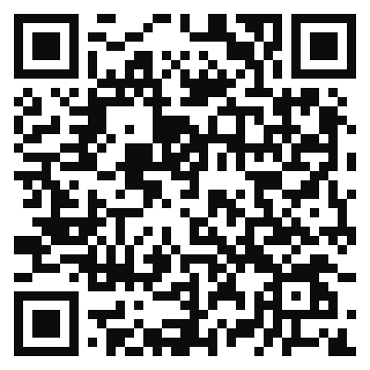 | 
Armorgators Contest Website | Facebook | Armorgator Bling

